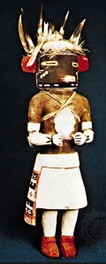**Hopi Technique for Dispersed Pain**

1. Spinal flush
2. Starting at top of spine if client gets headaches, or at the waist if not, curl fingers and use your hands, one on top of the other, so that each set of fingers presses down on one side of the spine. With some pressure, laser energy down through the body out of your fingertips, whilst sliding them down the spine.
3. Next, travel up the spine from the waist, bunching the client’s skin in your hands (check that they don’t dislike it first). Don’t go further up than is easy and comfortable for them.
4. Place flattened hands on the person’s shoulders and smooth down the back to the feet.
5. Return to the shoulder and smooth from one shoulder to the opposite hip then repeat on the other side. You can experiment with using bent fingers and some pressure.
6. Repeat 2-3 times and, on the last one, pull the energy down the body, and off the toes.

**Variation 1**

1. Spinal flush
2. Use both thumbs on the near side of the spine, and all your fingers on the far side of the spine to carry out the above steps..

**Variation 2**

1. Spinal flush
2. One set of curled fingers spirals the skin clockwise on the far side of the spine, whilst the other set spirals anticlockwise on the near side.
3. Slide hands down, as above, and continue on with the above steps.